Introduction To Programming Assignment

[Group no.19]

Names Of Group Members: -

Sudha Yadav (IEC2021075)

Sahil Yadav (IEC2021076)

Riddhi Kedia (IEC2021077)

Shivam Kumar Singh (IEC2021078)

Department of Electronics and Communication Engineering

Indian Institute of Information Technology, Allahabad

Guided by: Professor:

Md. Meraz Sir Dr. Mohammed Javed Sir

Merging of Arrays and Reversing the Merged Array

***Abstract* – Given two arrays a[] and b[], we are required to merge these two arrays into the third array c[] and reverse the third array.**

**I. INTRODUCTION**

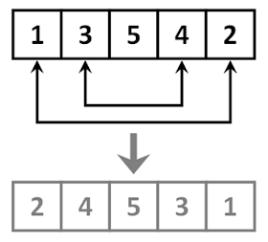

An array is defined as the collection of similar type of data items stored at continuous memory locations. It is the simplest data structure where each element can be randomly accessed by using its index number. It allows to store elements in any dimensional array like 1D, 2D and multi-dimensional array.

Merging of two arrays means combining two arrays into one single array. Given two arrays, if a[] contains p elements and b[] contains q elements then the merging of these two arrays will produce a third array c[] which will contain (p+q) elements. The final merged array is formed by writing the elements of the first array and then writing the elements of the second array. For example:

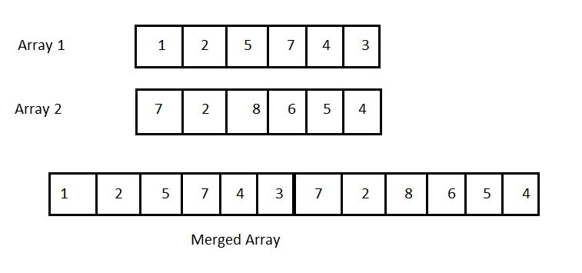

When the elements of the third array c[] are written in reverse order to its original format then the process is called to be reversing of the array. Sometimes this process is required by programmers to publish data in reverse order, therefore it becomes quite useful.

**II. ALGORITHM AND APPROACH**

In order to solve this problem, we have worked out the following approach required for the merging of 2 arrays and then reversing the merged array.

First, we would include a header file named stdio.h so that the compiler gets to know about the keywords used to code the programme. Then after using the main function, we would declare the variables p, q, r and i using the int function.

After that, we would ask the user about the no. of elements (p) in first array which is basically the array size declaration process. Then the declaration of array is done by using int a[p]. Similarly for the second array the size would be q and array will be written as b[q] and the third array will be c[r], where r=p+q.

We will take inputs of array elements from the user by using scanf statements and this process of taking inputs will be done by using for loop. Inside the for loop, we will be mentioning (initialization; condition; change). Now we start the for loop in which we assign i=0 as initialisation, i<=p-1 as condition and i++ for increasing the value of i each time inside the loop. Scanf function will use %d as format specifier and address of a[i]. Similarly for the second array, the above mentioned process will be executed where, i<=q-1 and &b[i] will be used.

Now for finding the third array c[r], we will have to merge a[p] and b[q]. We will apply for loop by assigning i=0, with condition i<=p-1 and by increasing i by 1 everytime. Then we equate c[i] = a[i]. Now again apply loop for i<=q-1 and c[i+x] =b[i]. Now again applying loop for i=o and i<=z-1 and increasing the value of i by 1 each time it is printing the elements of array c[r].

Now for finding the reverse of c[r] array, we will apply the for loop by assigning i=z-1 with condition i>=0 and decreasing the value of i by 1 (i--) every time in the loop. Hence the array will be printed in reverse order. Therefore, by these steps we have completed our program which is now ready to compile and run.

**III. PSEUDOCODE**

include<stdio.h>

int main(){

declaring variables, int p,q,r,i

printf(Enter the size of first array)

scanf (Address of p)

printf(Enter the size of second array)

scanf (Address of q)

r=p+q

int a[p],b[q],c[r]

printf(Enter the numbers for first array)

for(i=0;i<=p-1;i++){

scanf(Address of a[i])}

printf(Enter the numbers for second array)

for(i=0;i<=q-1;i++){

scanf(Address of b[i])}

printf(Merging the two arrays)

for(i=0;i<=p-1;i++)

c[i]=a[i]

for(i=0;i<=q-1;i++)

c[i+p]=b[i]

for(i=0;i<=r-1;i++)

printf( c[i])

printf(Reversing the third array)

for(i=r-1;i>=0;i--)

printf(c[i])

return 0;

}

**IV. CONCLUSION**

In order to solve the given problem, we made a program to merge any two arrays. Size of arrays and their elements are being decided and entered by the user. There after we have used for loops to merge the two arrays into the third array, and then finally reverse the third array. As an output the merged array and the reversed array are printed on the output screen.

**V. ACKNOWLEDGEMENT**

All the members of our team would like to express our special thanks to our respected Professor Dr. Mohammed Javed Sir and our Teaching Assistant Mr. Md. Meraz Sir and Tejasvee Bisen Mam for giving us this learning opportunity through this assignment which helped us to get more familiar with the concepts of array.

**VI. REFERENCES**

* <https://www.geeksforgeeks.org>
* <https://www.codescracker.com>

**VII. APPENDIX**

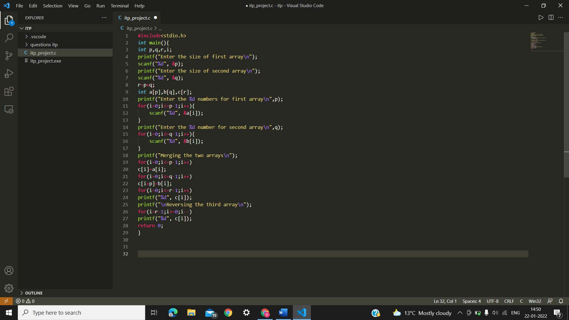

**VIII. OUTPUT**

In this example, the user has input the size of first array to be 4, and the size of the second array to be 5.

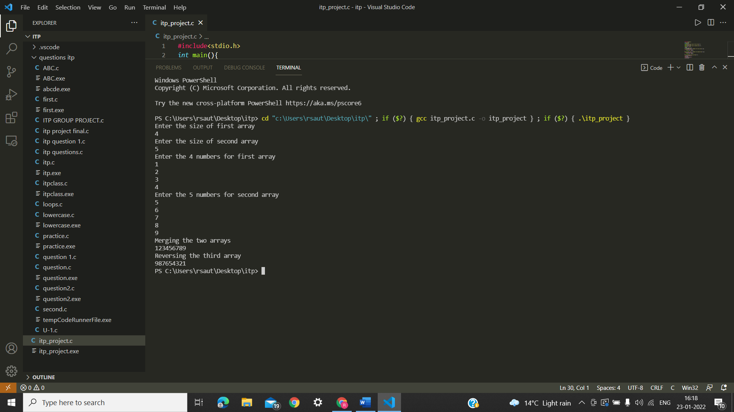

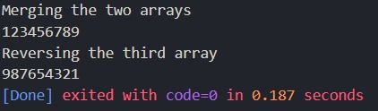

RUN TIME OF CODE= 0.187 seconds